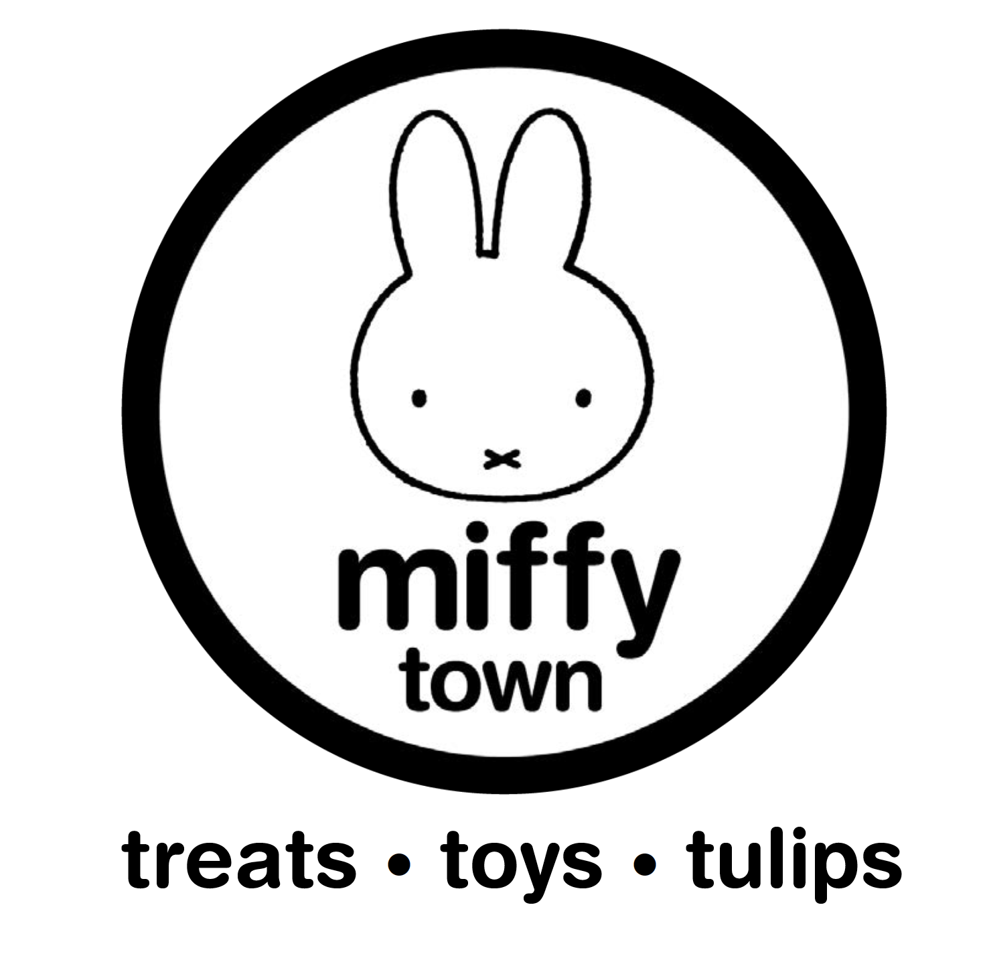

About Miffytown

Miffytown, located in Williamstown, KY was founded by Netherlands native and local entrepreneur Hans Philippo. Inspired by his childhood memories, Hans had a vision to bring the beloved character of Miffy to his community.

Miffy, a curious, optimistic bunny created by Dutch artist Dick Bruna, has been a beloved character in the Netherlands for over 60 years. Hans’ passion and love for Miffy is at the heart of Miffytown, offering a touch of nostalgia for parents and a playful new friend for children.

Miffytown brings to life the bright, colorful illustrations and engaging details found within the original artwork of the beloved character Miffy. Visitors to Miffytown will enter a world where they are encouraged to explore, imagine, and play. The interactive garden area is a highlight of Miffytown, where children can plant seeds and bulbs and then take them home to watch them grow. Storytime and Miffy movies are featured daily, giving children the opportunity to hear more about Miffy and her friends while learning about colors, shapes, and numbers, as well as simple life lessons.

Miffy navigates the world as a young child would, with a keen sense of curiosity and unbridled optimism, as she and her friends embark on new adventures of discovery. Miffytown provides children with the opportunity to explore the world in a warm and inviting environment where they are encouraged to be curious. With a keen focus on nature and the environment, Miffytown creates the connection between simple everyday experiences and the magic of exploration and learning.

Miffytown is more than just a place to play, it is a destination where families can create cherished memories together while fostering a love of learning and imagination in their children. Come visit us and be a part of the magic of Miffy and her friends. Join us in exploring the wonders of nature and the world around us and make lasting memories that will be treasured for years to come. We look forward to welcoming you to Miffytown.

